My name is Maureen Cattieu! Ms. Meli and I are so happy to be teaching at COJOWA!
We are already off to a great start and are going to have a wonderful year together!

A Brief Background:
I, Maureen Cattieu attended The University at Buffalo for both my Undergraduate and Graduate studies. I received a Bachelor’s degree in Early Childhood and Psychology with a minor in both Spanish and Education. I also graduated from the University with my Masters degree in Childhood Education with a Bilingual Extension.
I have taught in preschool, first grade and fifth grade classrooms in the United States and this will be my seventh year teaching first grade at COJOWA. I am dedicated to my students and make it a personal responsibility to create lessons and activities that truly captivates and motivates my students to think critically and work together in order to solve challenging problems. I know that we will have a great time and learn a lot together!

My Contact Information:
Ms. Maureen Cattieu
maureen.cattieu@cojowa.edu.co

Ms. Meli graduated from the University of San Buenaventura, where she studied modern languages: English and French. She has taught in various bilingual schools in Cartagena and is very excited to start her first year here with us at COJOWA. She loves working with children and is happy to be in a strong learning atmosphere where you can learn and share with everyone!

It is important to remember that parents and teachers must work together in order to provide the best possible education for our children.

Homework
Reading & Math Logs: All students will have a reading and math log. Students are required to fill in the titles of the books they read on RazKids Monday-Thursday and then turn in the reading log on FRIDAY. Likewise, they will have an IXL Math Skill log, which will have selected skills for them to practice during the week and require a parent signature upon completion.
Please make sure your child is writing the title of the book they read and circling what they did on RazKids: Listen, Read or Quiz.
It is important that they learn to be independent and responsible learners.
It is extremely beneficial to have your children read the same book multiple times, in order to improve comprehension and fluency. Please take the time to read with your children and ask them questions, in order to ensure that they understand the vocabulary and main idea of the story.
Note: Students can read on RazKids, library books or books from home for the Reading Log.

Students may also receive worksheets in both Math and other subject areas for homework. ALL Reading & Math Logs, along with additional worksheets will be passed out to students on Monday at the beginning of every week so that they have a week to complete the assignments and logs. Turn in day for all homework and logs is Friday.
*All parent and teacher communication will take place via email and/or through our 1A What’s App Chat. Behavior notes will be made in the agendas. Students are responsible for bringing these agendas with them on daily basis to school in order to record important events and homework assignments.
Parents should sign or initial their agenda every night!

ALL STUDENTS WILL HAVE A HOMEWORK FOLDER WHICH WILL BE BROUGHT TO SCHOOL DAILY, ALONG WITH THEIR AGENDAS!

*Student’s behavior color will also be shaded on the current day in their agendas, so please be sure to check your student’s behavior chart on a daily basis.
*Any comments, questions or concerns should be emailed to the teacher. Our 1A What´s App Chat is for whole group information and messages.

BEHAVIOR COLOR CHART |  | Positive Behavior Rewards:
Purple- I had an AMAZING Day in 1A and showed excellent behavior and I deserve an ice cream when I go home! =) =) |  | White Tickets are distributed to individual students whenever they are caught following directions or exhibiting positive behavior.  Once a month during the Flag Ceremony, Mr. Glab will select one ticket from the ticket jar to award one student as the Fabulous First Grader.
Green- I followed all the rules in class and had a great day in class. =) |  | White Tickets are distributed to individual students whenever they are caught following directions or exhibiting positive behavior.  Once a month during the Flag Ceremony, Mr. Glab will select one ticket from the ticket jar to award one student as the Fabulous First Grader.
Yellow- I had some trouble following all the rules of the class and had to have a private talk with my teacher. =( |  | REACHES tickets are distributed to individual students whenever they are caught showing one of our REACHES behaviors. Once a month during the Flag Ceremony, Mr. Glab, Ms. Angie and Ms. Juli pick from the bucket of REACHES tickets to award students with special prizes.
Red- I did not have a good day and was not following the rules of the class. I had to miss a recess or go talk to Mr. Glab or Ms. Angie. =( =( |  | REACHES bracelets are given to students who show repeated demonstrations of the the REACHES behaviors.

REACHES
School Wide Behavior Program
Responsibility
Empathy
Assertion
Cooperation
Honesty
Excellence
Self-Control
Please remember that student’s behavior and values is very important here at COJOWA. Their behavior will be graded each marking period, based on the REACHES rubric.
RULES OF CLASS 1A:
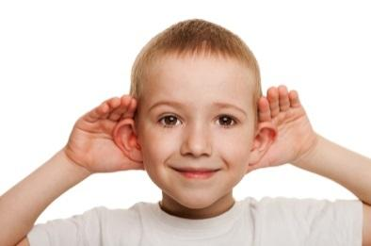
Rule # 3. Raise your hand to speak.
Rule # 2. Follow Directions QUICKLY!
Rule # 1. Listen when your teacher’s talking.

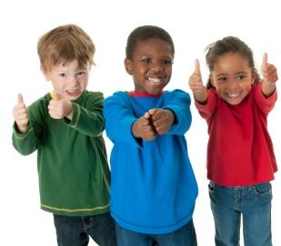

Rule # 5. Make smart choices and be happy!
Rule # 4. Use Self-Control

First Grade Curriculum

English (reading and writing)
This year we will be doing a Lucy Calkin´s reading and writing workshop on a daily basis. Students will be provided with time to work whole group, in small groups and independently during the course of the workshops. Students will also participate in guided reading and writing activities on a weekly basis. Daily Language Instruction, Sight Words and Spelling are also a component to our reading and writing classes. We use the Common Core State Standards in order to plan our reading and writing activities and assessments.
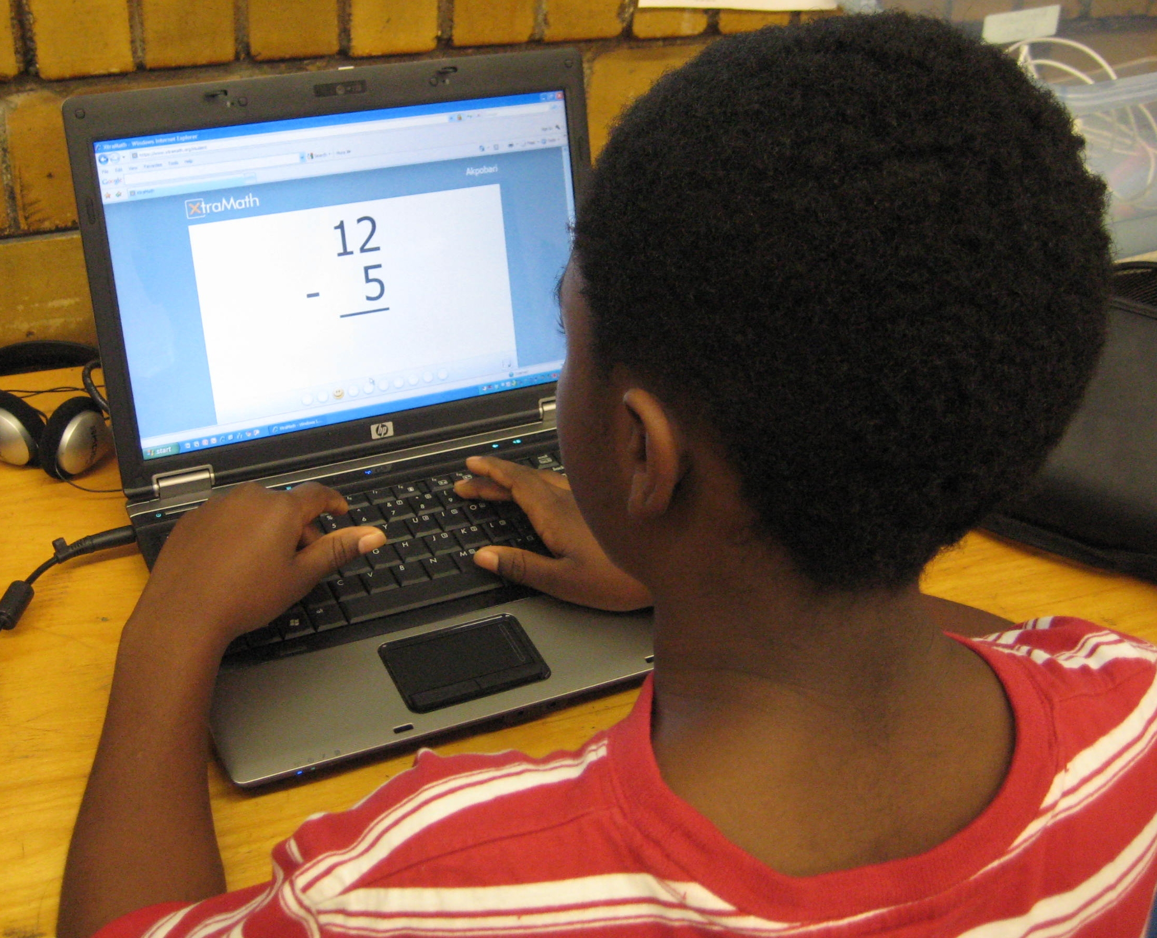
Math
We will be using the Eureka program, aligned with CCSS. Eureka Math connects math to the real world in ways that take the fear out of math and build student confidence. We also utilize IXL, as an online platform designed to reinforce the same math skills we are practicing in class.
Science Social Studies:
We use the Next Generation Science Standards We use the Colorado State
for our science curriculum here at COJOWA. Social Studies Standards,
Topics this year for science will be: and the TCI Social Studies Alive
Earth & Science: program. Topics this year for social
Weather and Seasons studies will be:
Objects in the Sky Civics:
Life: How do we get along in school?
Animals How are we good helpers at school? Plants Geography:
Physical: What is a map?
Light Economics:
Sound Who helps us at School?
History:
What are family traditions?

First Grade Standards-Based Grading Scale:
